الجمهورية اللبنانية
وزارة التربية والتعليم العالي الامتحانات الرسمية لشهادة الامتياز الفني
المديرية العامة للتعليم المهني والتقني لدورة عام 2012 الاولى
===============
الاختصاص والرمز : المعلوماتية الادارية (24004) –الانظمة والشبكات (24101)
المادة : التطوير التطبيقي بالانترنت – البرمجة بلغة الانترنت المعدل: (8-6)
المستندات المسموح بها : لا شيء المدة : ساعة ونصف

N.B: All the "HTML" files are in the folder: \web
All the "AUDIO" and "VIDEO" files are in the folder: \web\sounds
All the "IMAGES" files are in the folder: \web\photo
All others files are in the folder: \misc

- Give 4 different attributes that can be used with each of the following tags:
<img> , <option>
(2 pts)
II- Write the appropriate tags to obtain as a result the following page " page1.html" respecting the following conditions:  (3 pts)  - The words “training” and “middle east” are used for the search engine.  - The title has the biggest possible size.  - The title color is red  - The image name is « picture1.jpg »  - The border thickness of the picture is 2 pixels.  - The media file “hello.wav” should be played in the background when this page is opened. | 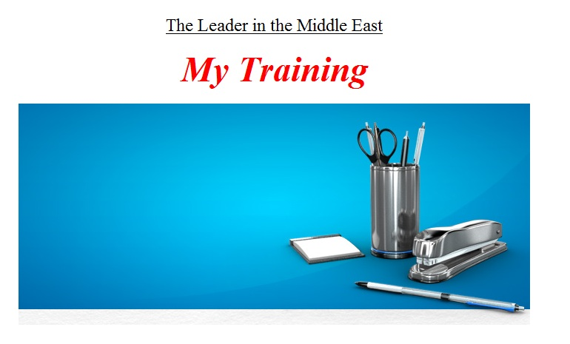
III- Write the appropriate tags to obtain as a result the following page " courses.html" respecting the following conditions:  (4 pts)  - The page author is “my name”  - The page background color is blue.  - The table background is white.  - The link “Download the Catalogue” download the file “cat.pdf”  - The table border color is red.  - The distance between the text and the table border is 2 pixels.  - The Distance between the cells is 4 pixels.  - The table is centered. | 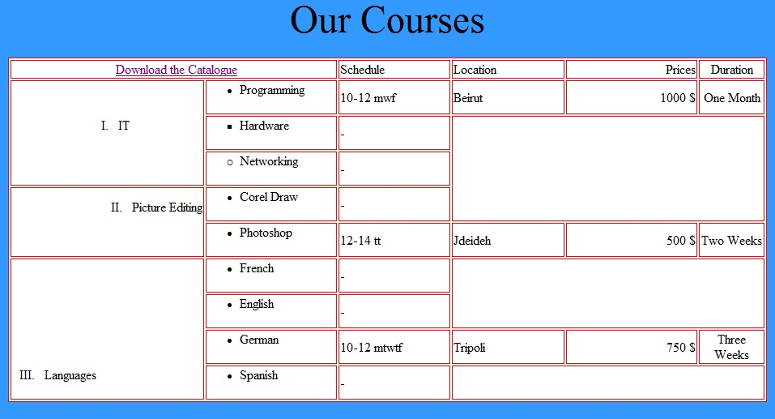

الاختصاص والرمز : المعلوماتية الادارية (24004) –الانظمة والشبكات (24101)
المادة : التطوير التطبيقي بالانترنت – البرمجة بلغة الانترنت المعدل: (8-6)
المستندات المسموح بها : لا شيء المدة : ساعة ونصف

 | IV- Write the appropriate tags to obtain as a result the following page " request.html" respecting the following conditions:  (4 pts)  - First Name: Entry field of 40 characters of which 20 are viewable.  - Last Name: Entry field of 20 characters.  - Comment: Total Characters of this entry field is 60 Characters spread over 3 lines.  - Phone Number: Entry field of 8 characters.  - Topics: Choice between 3 values “it”, “Picture Editing” and “Languages”.  - Join Mailing List: Choice between “yes” or “No”  - Email Address: Entry filed of 26 characters. Each character typed should be replaced by *.  - Location: Choice between “Beirut”, “Jdeideh” and “Tripolie”. The choice “Tripolie” should be selected by default. The user can choose all locations.  - A Submit button that will send the values to a file named “action.asp”.  - A Reset button to restore the default values. | 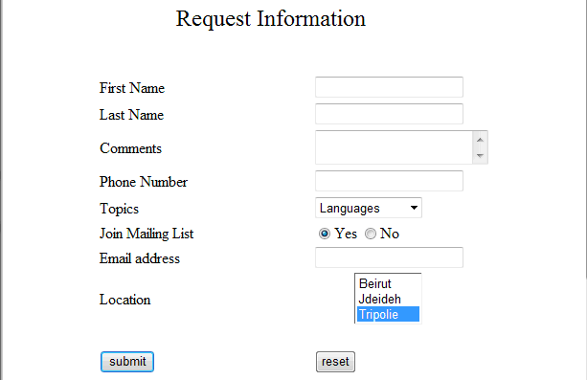
Frame B:
Width 10 %
Height:80%
V- Write the appropriate tags to obtain as a result the following page " first.html" respecting the following conditions  (7 pts)  - This page is divided into 4 frames A, B, C and D.  - The first frame "A" displays the image “img3.jpg” and the phrase “Don’t hesitate to call us any time” as a scrolling message from right to left five times.  - The second frame "B" contains the following links:  - “Main Page” displays the page “page1.html” in the frame D.  - “Catalogue” displays the page “courses.html” in the frame D  - “Request Info” displays the page “request.html” in the frame D.  - “google.com” displays the page “google.com” in the frame D.  - The image name is “img4.jpg”  - A click on the picture will send an email with a default subject “hello” to the following address “support@training.com.lb”.  - The frame C holds the phrase “Copyright @ 2012”. The background of this phrase is yellow.  - The fourth frame D displays by default “page1.html”  - Create all needed and not exiting pages, and add all needed tags to the existing pages. | Frame A:  Width: 100 %  Height: 10%  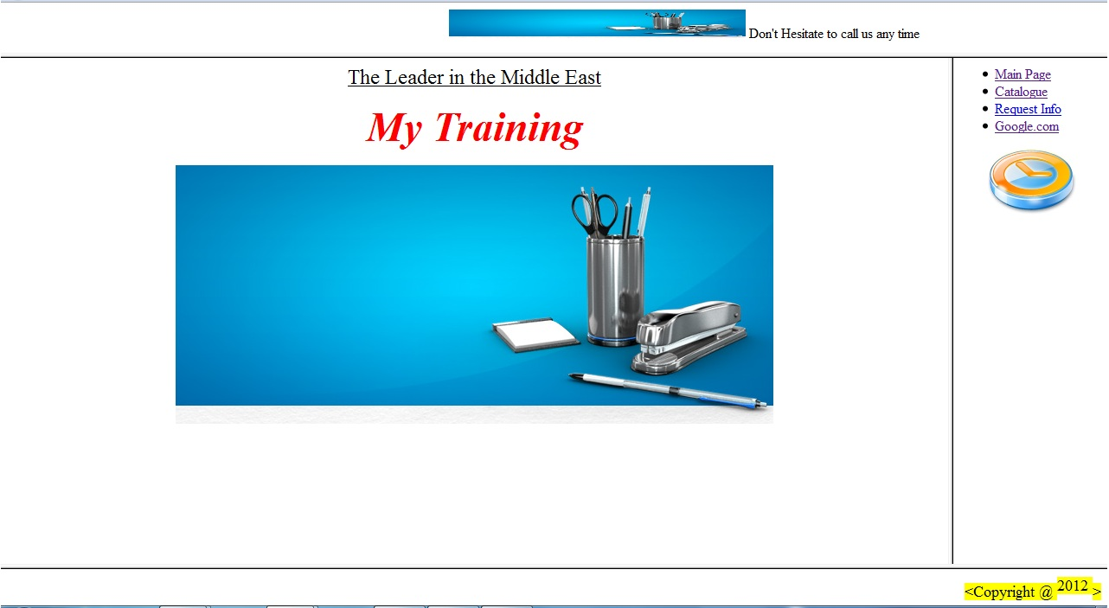  Frame C:  Width 100 %  Height:10%  Frame D:  Width 90 %  Height:80%

